11.2 Tests for acids and bases
Name: ____________________ Class: ____________________ Due date:
2 . A gas is escaping from a pipe in a chemical plant. A chemist tests this gas and finds that it is alkaline. What is this gas?
A ammonia B chlorine C hydrogen D sulfur dioxide

Four different gases are passed through the apparatus shown.
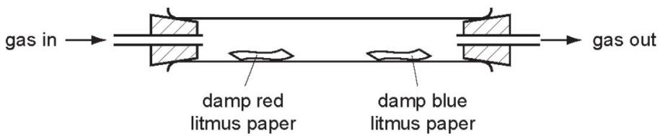
Which gas has no effect on either piece of litmus paper?
A ammonia B carbon dioxide C chlorine D hydrogen

Two indicators, bromophenol blue and Congo red, show the following colours in acidic solutions and in alkaline solutions.
indicator | acid | alkali
bromophenol blue | yellow | blue
Congo red | violet | red
A few drops of each indicator are added to separate samples of a solution of pH 2.
What are the colours of the indicators in this solution?
 | in a solution of pH 2
 | bromophenol blue is | Congo red is
A | blue | red
B | blue | violet
C | yellow | red
D | yellow | violet

The table shows the pH of four aqueous solutions, W, X, Y and Z.
substance | pH
W | 7
X | 9
Y | 2
Z | 5
Universal Indicator is added to each solution.
Which row shows the colour of each solution after the indicator is added?
 | W | X | Y | Z
A | blue | green | orange | red
B | green | blue | red | orange
C | orange | red | blue | green
D | red | orange | green | blue

Which statement is not correct?
A When a base reacts with an ammonium salt, ammonia is given off.
B When an acid reacts with a base, neutralisation takes place.
C When an acid reacts with a carbonate, carbon dioxide is given off.
D When the acidity of a solution increases, the pH increases.

Aqueous sodium hydroxide is added to solid Q in a test- tube.
A gas is produced which turns damp red litmus blue.
What is Q?
A aluminium B ammonia C ammonium chloride D sodium nitrate

Potassium hydroxide is a base.
Which statement describes a reaction of potassium hydroxide?
A Chlorine is formed when it is heated with ammonium chloride.
B It turns Universal Indicator green.
C It reacts with an acid to produce a salt and water.
D It turns methyl orange red.

A few drops of methyl orange are added to a reaction mixture.
During the reaction, a gas is produced and the methyl orange turns from red to orange.
What are the reactants?
A aqueous sodium hydroxide and ammonium chloride
B aqueous sodium hydroxide and calcium carbonate
C dilute hydrochloric acid and magnesium
D dilute hydrochloric acid and aqueous sodium hydroxide

Ethanoic acid is a weak acid. Hydrochloric acid is a strong acid.
Which statements are correct?
1 Ethanoic acid molecules are partially dissociated into ions.
2 1.0 mol/dm ethanoic acid has a higher pH than $1.0mol/{dm}^{3}$ hydrochloric acid.
3 Ethanoic acid is always more dilute than hydrochloric acid.
4 Ethanoic acid is a proton acceptor.
A 1 and 2 B 1 and 3 C 2 and 4 D 3 and 4

Which row shows the difference between a weak acid and a strong acid?
 | weak acid | strong acid
A | fully ionised | partially ionised
B | concentrated | dilute
C | dilute | concentrated
D | partially ionised | fully ionised

Solutions of acid R and acid S have the same concentration.
The same volume of each acid at the same temperature is reacted with the same mass of magnesium ribbon.
The volume of hydrogen produced is measured.
The results are shown.
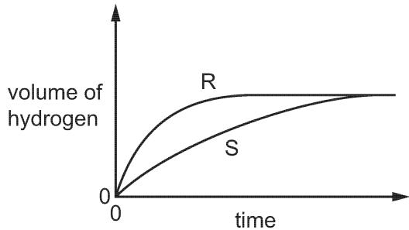
Which statement about the reactions is correct?
A Acid S reacts faster than acid R.
B The final volume of hydrogen produced in each reaction is different.
C Acid R is a stronger acid than acid S.
D Acid S is a stronger acid than acid R.

Which statement describes the properties of hydrochloric acid?
A Carbon dioxide is produced when limestone reacts with hydrochloric acid.
B Hydrogen is produced when sodium hydroxide reacts with hydrochloric acid.
C Methyl orange turns yellow in strong hydrochloric acid.
D Red litmus paper turns blue when dipped into hydrochloric acid.

Sulfuric acid is a strong acid. You are given aqueous sulfuric acid, concentration $0.1{\text{mol / dm}}^{3}$ , and aqueous hexanesulfonic acid, concentration $0.2{\text{mol / dm}}^{3}$ . Describe how you could show that hexanesulfonic acid is also a strong acid.
..................................................................................................................................
..................................................................................................................................
..................................................................................................................................[2]
Deduce why, for a fair comparison, the two acid solutions must have different concentrations.
..................................................................................................................................[1]
Explain the terms strong acid and weak acid.
..................................................................................................................................
..................................................................................................................................
..................................................................................................................................[2]

